**Keyword based exploration of Library Sources**

## A PROJECT REPORT

***Submitted by,***

|  |  |
| --- | --- |
| **Sahana H** | **20211CSG0017** |
| **Sangeetha S K** | **20211CSG0003** |
| **Amrutheshwari V S** | **20211CSG0037** |
| **Sunitha Gahana** | **20211CSG0038** |

### *Under the guidance of,*

**Dr. Manjula H M**

***in partial fulfillment for the award of the degree of***

**BACHELOR OF TECHNOLOGY**

**IN**

**COMPUTER SCIENCE AND TECHNOLOGY**

**At**



**PRESIDENCY UNIVERSITY**

**BENGALURU**

**DECEMBER 2024**

**PRESIDENCY UNIVERSITY**

**PRESIDENCY SCHOOL OF COMPUTER SCIENCE ENGINEERING**

**CERTIFICATE**

This is to certify that the Project report **“Keyword based exploration of Library Sources”** being submitted by “Sahana H, Sangeetha S K, Amrutheshwari V S, Sunitha Gahana” bearing roll numbers “20211CSG0017, 20211CSG0003, 20211CSG0037, 20211CSG0038” in partial fulfillment of the requirement for the award of the degree of Bachelor of Technology in Computer Science and Engineering is a Bonafide work carried out under my supervision.

|  |  |
| --- | --- |
| **Dr. Manjula H M**  Associate Professor  Presidency School of CSE&IS  Presidency University | **Dr. Saira Banu**  Professor & HoD  Presidency School of CSE&IS  Presidency University |

|  |  |  |
| --- | --- | --- |
| **Dr. L. SHAKKEERA**  Associate Dean  Presidency School of CSE  Presidency University | **Dr. MYDHILI NAIR**  Associate Dean  Presidency School of CSE  Presidency University | **Dr. SAMEERUDDIN KHAN**  Pro-Vc School of Engineering  Dean – Presidency School of CSE  Presidency University |

**PRESIDENCY UNIVERSITY**

**PRESIDENCY SCHOOL OF COMPUTER SCIENCE ENGINEERING**

**DECLARATION**

We hereby declare that the work, which is being presented in the project report entitled **KEYWORD BASED EXPLORATION OF LIBRARY SOURCES** in partial fulfillment for the award of Degree of **Bachelor of Technology** in **Computer Science and Engineering**, is a record of our own investigations carried under the guidance of **Dr. Manjula H M,** Associate Professor, **Presidency** **School of Computer Science Engineering, Presidency University, Bengaluru.**

We have not submitted the matter presented in this report anywhere for the award of any other Degree.

|  |  |
| --- | --- |
|  | **Sahana H 20211CSG0017**  **Sangeetha S K 20211CSG0003**  **Amrutheshwari VS 20211CSG0037**  **Sunitha Gahana 20211CSG0038** |

**ABSTRACT**

The project, titled "Keyword-Based Exploration of Library," focuses on developing an online platform for accessing medical research papers efficiently. With the increasing demand for medical knowledge, the platform aims to provide students, researchers, and professionals with a simplified process to search, view, and download relevant research papers. The system integrates a keyword-based search mechanism to enhance the user experience by enabling quick access to specific papers. The platform consists of two main modules: Admin and User. The Admin module allows administrators to upload, manage, and delete research papers, ensuring the platform stays up-to-date. The User module enables users to log in securely, search for papers, view detailed information, and download the paper they require. The system employs secure user authentication to protect sensitive content and prevent unauthorized access. The objective is to create an efficient, user-friendly environment that simplifies the process of accessing medical research papers. Ultimately, the project aims to improve the accessibility, organization, and distribution of valuable academic resources, making medical research more accessible to a global audience.

**ACKNOWLEDGEMENT**

First of all, we indebted to the **GOD ALMIGHTY** for giving me an opportunity to excel in our efforts to complete this project on time.

We express our sincere thanks to our respected dean **Dr. Md. Sameeruddin Khan**, Pro-VC, School of Engineering and Dean, Presidency School of Computer Science Engineering, Presidency University for getting us permission to undergo the project.

We express our heartfelt gratitude to our beloved Associate Deans **Dr. Shakkeera L and Dr. Mydhili Nair,** Presidency School of Computer Science Engineering, Presidency University, and **Dr. Saira Banu**, Head of the Department, Presidency School of Computer Science Engineering, Presidency University, for rendering timely help in completing this project successfully.

We are greatly indebted to our guide **Dr. Manjula H M,** Associate Professor and Reviewer **Dr. Madhusudhan M V**, Associate Professor, Presidency School of Computer Science Engineering, Presidency University for her inspirational guidance, and valuable suggestions and for providing us a chance to express our technical capabilities in every respect for the completion of the project work.

We would like to convey our gratitude and heartfelt thanks to the PIP2001 Capstone Project Coordinators **Dr. Sampath A K, Dr. Abdul Khadar A and Mr. Md Zia Ur Rahman,** department Project Coordinators **Dr. Manjula H M** and Git hub coordinator **Mr. Muthuraj.**

We thank our family and friends for the strong support and inspiration they have provided us in bringing out this project.

|  |
| --- |
| **Sahana H 20211CSG0017**  **Sangeetha S K 20211CSG0003**  **Amrutheshwari VS 20211CSG0037**  **Sunitha Gahana 20211CSG0038** |

**LIST OF TABLES**

|  |  |  |  |
| --- | --- | --- | --- |
| **Sl. No.** | **Table Name** | **Table Caption** | **Page No.** |
| 1 | Table 6.1 | Test Cases | 21 |
| 2 | Table 6.2 | Test Cases Model Building for User | 22 |
| 3 | Table 6.3 | Test Cases Model Building for Admin | 23 |

**LIST OF FIGS**

|  |  |  |  |
| --- | --- | --- | --- |
| **Sl. No.** | **Fig Name** | **Caption** | **Page No.** |
| 1 | Fig 4.1 | Work Flow of Proposed System | 9 |
| 2 | Fig 6.1 | Use Case Diagram | 13 |
| 3 | Fig 6.2 | Class Diagram | 14 |
| 4 | Fig 6.3 | Sequence Diagram | 15 |
| 5 | Fig 6.4 | Collaboration Diagram | 15 |
| 6 | Fig 6.5 | Deployment Diagram | 16 |
| 7 | Fig 6.6 | Activity Diagram | 17 |
| 8 | Fig 6.7 | Component Diagram | 18 |
| 9 | Fig 6.8 | ER Diagram | 18 |
| 10 | Fig 6.9 | DFD Diagram (Level 1) | 19 |
| 11 | Fig 6.10 | DFD Diagram (Level 2) | 20 |
| 12 | Screenshot 1 | Home Page | 35 |
| 13 | Screenshot 2 | About Page | 35 |
| 14 | Screenshot 3 | Register Page | 36 |
| 15 | Screenshot 4 | Login Page | 36 |
| 16 | Screenshot 5 | Search Paper | 37 |
| 17 | Screenshot 6 | View Paper | 37 |
| 18 | Screenshot 7 | View Individual Paper | 38 |
| 19 | Screenshot 8 | Admin Home Page | 38 |
| 20 | Screenshot 9 | Add Papers | 39 |
| 21 | Screenshot 10 | Delete Papers | 39 |
| 22 | Screenshot 11 | SDGs | 40 |
| 23 | Screenshot 12 | Plagiarism check | 42 |

**TABLE OF CONTENTS**

|  |  |  |
| --- | --- | --- |
| CHAPTER NO. | TITLE | PAGE NO. |
|  | **CERTIFICATE**  **DECLARATION**  **ABSTRACT ACKNOWLEDGMENT**  **List of Tables**  **List of Figs** | **ii**  **iii**  **vi**  **v**  **vi**  **vii** |
| 1. | **INTRODUCTION** | 1 |
|  | 1.1 Motivation | 1 |
|  | 1.2 Problem Statement | 1 |
|  | 1.3 Objective of the project | 1 |
|  | 1.4 Scope of the Project | 2 |
|  | 1.5 Project Introduction | 2 |
| 2. | **LITERATURE REVIEW** | **3** |
|  | 2.1 Review of Related Works | 3 |
| 3. | **RESEARCH GAPS OF EXISTING METHODS** | 6 |
|  | 3.1 Overview | 6 |
|  | 3.2 Disadvantages | 6 |
|  | 3.3 Advantages | 7 |
| 4. | **PROPOSED METHODOLOGY** | 8 |
|  | 4.1 Proposed System | 8 |
|  | 4.2 Work Flow | 9 |
| 5. | **OBJECTIVES** | **10** |
|  | 5.1 Overview | 10 |
|  | 5.2 Objectives of Input Design | 10 |
|  | 5.3 Objectives of Output Design | 11 |
| 6. | **System Design & Implementation** | **13** |
|  | 6.1 Introduction of Input Design | 13 |
|  | 6.2 UML Diagrams | 13 |
|  | 6.2.1 Use Case Diagram | 13 |
|  | 6.2.2 Class Diagram | 14 |
|  | 6.2.3 Sequence Diagram | 14 |
|  | 6.2.4 Collaboration Diagram | 15 |
|  | 6.2.5 Deployment Diagram | 16 |
|  | 6.2.6 Activity Diagram | 16 |
|  | 6.2.7 Component Diagram | 17 |
|  | 6.2.8 ER Diagram | 18 |
|  | 6.3 DFD Diagram | 19 |
|  | 6.4 Feasibility Study | 20 |
|  | 6.5 Types of Tests | 21 |
| 7. | **Timeline** | **26** |
| 8. | **Outcomes** | **27** |
| 9. | **Results and Discussions** | **28** |
|  | 9.1 Results and Discussions | 28 |
| 10. | **Conclusion** | **29** |
|  | 10.1 Future Enhancement | 29 |
| 11. | **References** | **30** |
| 12. | **APPENDIX-A, PSUEDOCODE** | **32** |
| 13. | **APPENDIX-B, SCREENSHOTS** | **34** |
| 14. | **APPENDIX-C, ENCLOSURES** | **39** |

**CHAPTER-1**

**INTRODUCTION**

* 1. **Motivation:**

The motivation behind this project is to create an efficient, user-friendly platform that facilitates easy access to medical research papers from multiple reputable sources, including IEEE, PubMed, and Google Scholar. With the increasing demand for medical knowledge, it is crucial to provide a streamlined process for both researchers and students to search, download, and manage academic resources. This system aims to enhance the distribution of medical research by offering a flawless browsing experience. By incorporating an automatic search function and secure user authentication, the platform ensures a sturdy and reliable environment. The project also seeks to simplify content management for administrators, enabling them to upload and maintain research papers with ease. Ultimately, this project strives to bridge the gap between medical research and its users.

* 1. **Problem Statement:**

The lack of a centralized platform for accessing IEEE, PubMed, and Google Scholar medical research papers presents a challenge for students and researchers seeking efficient access to relevant content. Current systems may not provide an intuitive search mechanism or easy navigation, making it difficult to find specific papers.[3] Additionally, content management for administrators often lacks streamlined tools for uploading and maintaining research papers. There is also a need for secure login and user authentication to ensure authorized access to resources. This project addresses these issues by providing a user-friendly platform with advanced search features, secure login, and efficient content management for administrators.

* 1. **Objective of the Project:**

The objective of this project is to develop a platform that allows users to access, search, and download IEEE, PubMed, and Google Scholar medical research papers efficiently. It aims to provide with tools to manage and upload research content seamlessly. The system will include secure user authentication for both admins and users. By implementing a keyword-based search, the project seeks to enhance the user experience in locating specific papers.

* 1. **Scope:**

The scope of this project includes the development of an online platform for managing and accessing IEEE, PubMed, and Google Scholar medical research papers. It will offer two user modules: one for Admins to manage and upload papers, and one for Users to search, view, and download papers. The system will feature keyword-based search functionality to enhance the user experience in finding relevant papers. Additionally, it will include secure login mechanisms for both users and administrators. The platform aims to support the efficient management and dissemination of medical research resources. Future expansions may include integrating more research databases and enhancing content organization.

* 1. **Project Introduction:**

The project aims to develop an online platform for managing and accessing IEEE, PubMed, and Google Scholar medical research papers, providing a centralized system for users and administrators. The platform will be divided into two primary modules: **Admin** and **User**. The **Admin** module will enable administrators to upload, manage, and delete research papers, ensuring that the platform remains up-to-date with the latest medical research. The **User** module will allow users to log in, search for research papers using relevant keywords, view detailed information, and download the papers for further study. Additionally, the system will ensure secure authentication for both admins and users to protect sensitive content and data. By implementing an intuitive user interface and efficient search features, this platform will simplify the process of accessing IEEE medical research papers, making valuable academic resources more accessible to students, researchers, and professionals in the medical field. The project aims to improve the management and dissemination of medical knowledge through a user-friendly and secure digital library system.

**CHAPTER-2**

**LITERATURE SURVEY**

The primary focus of this literature survey is to explore existing technologies and methodologies in keyword extraction, academic content management, and secure data access within digital libraries. It highlights the limitations of current systems and suggests potential solutions for creating a more efficient platform for accessing research papers. Key areas of investigation include keyword extraction techniques, academic search system optimization, secure access and content management, and user interface design to enhance user experience.

**2.1 Review of Related Works:**

**Xie, Ruixia et al. [1]** in this paper explores the integration of keyword extraction with topic analysis and literature recommendations based on topic similarity. The system achieved a high accuracy rate of 86.36% and a recall rate of 67.29%, outperforming traditional methods. This paper reviews the effectiveness of keyword-based recommendations in libraries, although it faced challenges with lower recall due to a high similarity threshold. It underscores the significance of robust keyword extraction algorithms, offering valuable insights for enhancing search functionality and paper recommendations in the Keyword Based Exploration of Library Sources project.

**C. Zhang et al. [2]** propose a novel method to improve keyword extraction from academic articles by leveraging highlights. This approach integrates highlights and abstracts, using advanced iterative graph algorithms for unsupervised keyword extraction. The study demonstrates that combining highlights with abstracts enhances the accuracy and relevance of extracted keywords. However, the research also identifies limitations, as highlights alone fail to provide comprehensive keyword coverage. The findings contribute significantly to refining keyword-based searches, offering practical applications for enhancing the precision of extracted keywords in academic platforms.

**E. Scheme et al. [3]** introduce an open-source library designed to support the exploration and development of myoelectric control systems. The library provides researchers and developers with a flexible and extensible platform for testing and implementing control strategies. The study highlights the library's capacity to streamline experimentation, enabling enhanced usability and adaptability for diverse applications. This resource addresses the need for accessible tools in the field of myoelectric control and represents a significant step forward in fostering innovation and collaboration within the research community.

**S. Bratt [5]** investigates user search session patterns within an image-based digital library, focusing on how users navigate and interact with visual content. The study analyzes various session behaviors, including search strategies, query refinement, and result exploration, to identify common trends and challenges. The findings provide insights into optimizing digital library interfaces to improve user experience and retrieval efficiency. This work underscores the importance of understanding user behavior for developing more intuitive and effective search systems in visual information repositories.

**J. T. Lee et al. [10]** present a comprehensive study on the development of secure online systems for managing and accessing academic papers. The research emphasizes the importance of robust authentication mechanisms, encryption, and data integrity to ensure user privacy and system reliability. Their findings contribute to the creation of secure platforms that facilitate seamless academic resource sharing while addressing security vulnerabilities in traditional systems.

**M. T. Elahi et al. [11]** explore the role of metadata in enhancing the functionality and efficiency of academic search systems. The survey highlights various metadata models and their impact on improving search accuracy, relevancy ranking, and information retrieval. The study underscores metadata's critical role in bridging gaps between user queries and resource discovery, providing valuable recommendations for designing metadata-driven search platforms.

**D. S. Patel et al. [12]** conduct a comparative analysis of medical research paper repositories, evaluating their features, usability, and accessibility. The study identifies strengths and weaknesses across various platforms, offering a detailed examination of data organization, search functionalities, and user interface designs. The findings serve as a guide for improving repository design and functionality to better serve the medical research community.

**Q. Li and T. Zhang [15]** present a framework for secure data sharing and access control in medical research repositories. Their study focuses on employing encryption techniques, role-based access control, and blockchain technology to ensure secure and transparent data management. The proposed methods address challenges in maintaining data confidentiality, integrity, and traceability, providing a robust solution for secure collaboration in medical research environments.

**R. Kumar and S. P. Singh [16]** review efficient search algorithms designed for medical research databases, focusing on their impact on query performance and result relevance. The study categorizes various algorithms, highlighting their strengths and limitations in handling large-scale medical datasets. Their findings provide a foundation for optimizing search methodologies in medical research systems, ensuring quicker and more precise information retrieval for researchers.

**CHAPTER-3**

**RESEARCH GAPS OF EXISTING METHODS**

**3.1 Overview**

The existing systems for accessing medical research papers, such as IEEE Xplore, PubMed, Google Scholar, and Elsevier ScienceDirect, offer vast collections of research papers but have notable limitations. Many platforms require institutional access or subscriptions to view full papers. Search functionality often requires advanced knowledge of keywords and filters, making it challenging for casual users.[2] Additionally, user interfaces can be cumbersome and not always intuitive, hindering efficient navigation. Open access repositories provide free content but may lack the latest papers or have limited search capabilities. Overall, existing systems do not offer an integrated, seamless experience for secure and easy access to medical research papers. Despite the availability of multiple platforms and tools to access research papers, existing methods have significant limitations when it comes to addressing the specific needs of DIPLOMATE OF NATIONAL BOARD students and their guides. These shortcomings arise from issues related to accessibility, integration, and functionality, which impede efficient research.[4] Identifying these gaps forms the foundation for developing an improved solution tailored to their requirements.

**3.2 DISADVANTAGES**

1. **Access Restrictions**: Many platforms, such as IEEE Xplore and Elsevier ScienceDirect, require subscriptions or institutional access, limiting availability for individual users or those without institutional affiliations.
2. **Complex Search Mechanisms**: Advanced search options on systems like PubMed and Google Scholar require users to have specific knowledge of search terms, Boolean operators, and filters, which can be challenging for non-expert users.
3. **Limited Integration**: Existing systems often do not provide seamless integration across different research repositories, leading to fragmented access to research papers and inefficiencies in searching across multiple sources.

**3.3 ADVANTAGES**

1. **Easy Access to Research Papers**: The system provides a centralized platform for users to easily search, view, and download IEEE, PubMed, and Google Scholar medical research papers, improving accessibility compared to traditional platforms.
2. **User-Friendly Interface**: With an intuitive design, the system ensures a smooth and efficient user experience, making it easy for both administrators and users to navigate and utilize the platform effectively.[3]
3. **Keyword-Based Search**: Users can quickly find relevant research papers through advanced keyword-based search functionality, enhancing the discoverability of content.[11]
4. **Secure Authentication**: The system includes secure login features for both users and administrators, ensuring that only authorized individuals can access and manage sensitive content.
5. **Efficient Content Management**: Admins can easily upload, manage, and organize research papers, ensuring the platform remains up-to-date and well-organized for seamless user access.[5]

**CHAPTER-4**

**PROPOSED METHODOLOGY**

* 1. **PROPOSED SYSTEM**

Existing platforms for accessing medical research papers, such as PubMed, IEEE Xplore, and Google Scholar, offer vast repositories of academic content but face significant usability and accessibility challenges. These systems often rely on advanced keyword search mechanisms and subscription-based models, creating barriers for casual users and independent researchers [2][5]. While metadata tagging and advanced search filters have improved retrieval accuracy in some systems, they are inconsistently implemented across platforms, limiting their effectiveness [7]. Moreover, integration across repositories remains a challenge, forcing users to navigate multiple systems to access a comprehensive set of resources.

Additionally, most platforms lack user-friendly interfaces and personalization options. For instance, while Baldonado’s user-centered design improved navigation, it failed to address the need for relationship recognition among documents [4]. Security concerns also persist, with many systems lacking robust authentication mechanisms to protect sensitive data [8]. The absence of real-time collaboration tools and advanced categorization further highlights the gaps in existing methodologies. These limitations underscore the need for an integrated solution that addresses accessibility, usability, and security concerns in a unified platform.

* 1. **Work Flow of Proposed system**

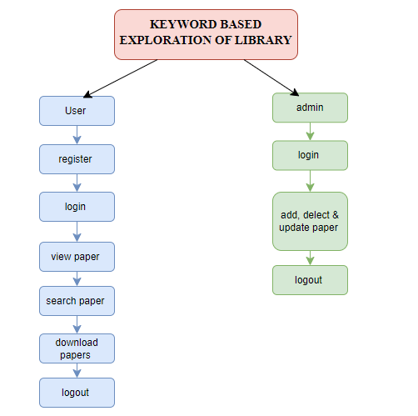

**Fig 4.1: Work Flow Diagram of the Proposed Library Management System [18]**

**CHAPTER-5**

**OBJECTIVES**

**5.1 Overview**

The project, "Keyword-Based Exploration of Library Sources," aims to develop a robust and user-friendly platform for accessing medical research papers. The increasing demand for academic resources necessitates a system that not only simplifies access but also ensures accuracy, security, and efficiency [1][2]. Existing platforms often fail to meet these requirements, presenting challenges such as limited keyword coverage, subscription barriers, and disorganized content [7].

The primary goal of this project is to create a platform that incorporates advanced keyword extraction techniques and metadata-driven search capabilities. By adopting approaches like metadata categorization [7], the platform enhances the precision and relevance of search results. Additionally, the integration of secure authentication protocols ensures protection against unauthorized access, following recommendations by Gupta and Choudhury (2022) [8].

To achieve these objectives, the system is divided into two primary modules: the Admin module for content management and the User module for resource access. Admins can upload, update, and delete papers, ensuring the repository remains up-to-date. Users, on the other hand, can perform keyword-based searches, view metadata, and download research papers securely.

This project emphasizes simplicity, usability, and security in its design, making it a comprehensive solution for researchers, students, and professionals seeking academic resources. By addressing the limitations of existing systems, it bridges the gap between medical research and its users, fostering an interconnected academic community [3][6].

**5.2 Objectives for Input Design**

Input design plays a crucial role in ensuring the accuracy, efficiency, and user-friendliness of the data entry process within the system. The mechanisms for data entry, validation, and integration directly impact the effectiveness of the platform [7]. The following objectives focus on enhancing the input process, ensuring both user satisfaction and system reliability.

1. User-Friendly and Intuitive Interfaces: The first objective is to develop intuitive and accessible interfaces for both administrators and users. Administrators will upload research papers by entering essential metadata, such as titles, authors, keywords, and abstracts. This follows the standards set by Patel et al. (2023) for organized and consistent data entry [6]. Users will be provided with dynamic search bars and filters, enabling them to input keywords or phrases efficiently.
2. Data Validation and Accuracy: A second objective is to incorporate robust validation mechanisms during data entry. This involves checks for missing or incorrect metadata, ensuring that only complete and accurate data is uploaded. Drawing from the work of Lee et al. (2019), these validation checks help reduce redundancy and improve the overall search accuracy of the system [9].
3. Secure Input Channels: Ensuring secure input channels is another key objective. The platform includes authentication layers during login and data upload, allowing only authorized personnel to access or modify the system. This aligns with Gupta and Choudhury’s (2022) research on secure input systems within academic repositories [8].
4. Organized and Reliable Data: Ultimately, the objective of the input design is to ensure that the system processes information accurately, in an organized manner, and in a way that enhances operational integrity. By focusing on these elements, the input system ensures a seamless experience for both administrators and users, contributing to the reliability and efficiency of the platform [1][3].

**5.3 Objectives of Output Design**

Output design aims to present the system’s data in an organized, accessible, and actionable way, ensuring that the information provided to users meets their expectations and is presented clearly. The objectives for output design are influenced by the needs for clarity, relevance, and user satisfaction [6].

1. Comprehensive and Relevant Information: The first objective is to design output that offers users detailed information about research papers. This includes essential metadata, such as titles, authors, publication years, and abstracts. The system's output design draws from Elahi et al. (2022), which emphasizes the role of well-defined metadata in enhancing the user experience [7].
2. Dynamic Search Outputs: A second objective is to refine the search outputs based on user input keywords. The platform should accurately retrieve and display relevant research papers with high precision. This approach follows the recommendations of Zhang and Zhao (2024), which advocate for using highlights and abstracts to improve the relevance of search results [2]. Additionally, advanced filters will allow users to narrow down their search based on parameters such as publication date or research domain.
3. Downloadable and Secure Outputs: Providing downloadable research papers in standardized formats, such as PDF, is another important objective. The system will ensure compatibility with various devices, facilitating seamless access to full-text papers. To protect these downloadable resources, security measures such as access control protocols will be incorporated, following the findings of Lee et al. (2019) on securing academic systems [9].
4. Clarity and Accessibility: Lastly, the output design prioritizes clarity and accessibility. The user interfaces will be optimized to ensure smooth navigation and efficient data retrieval, making the academic exploration process intuitive. By focusing on these objectives, the platform aims to set a standard for delivering high-quality outputs that meet the diverse needs of users [1][3].

**CHAPTER-6**

**SYSTEM DESIGN & IMPLEMENTATION**

**6.1 Introduction of Input Design**

Input design is a critical phase of the system development process, focusing on how data is entered into the system to produce accurate outputs. In the proposed platform, inputs include user credentials, search keywords, and metadata for uploading research papers. Input forms and screens are designed to ensure user-friendliness, accuracy, and validation. Features like dropdowns for predefined categories and error-checking mechanisms ensure reliable data entry.

**6.2 UML Diagrams:**

**6.2.1 Use Case Diagram:**

The use case diagram represents the interactions between users (Admins and Users) and the system. Admins manage the repository by adding, updating, or deleting papers, while users search, view, and download papers securely. The diagram highlights the system’s primary functionalities and their dependencies.

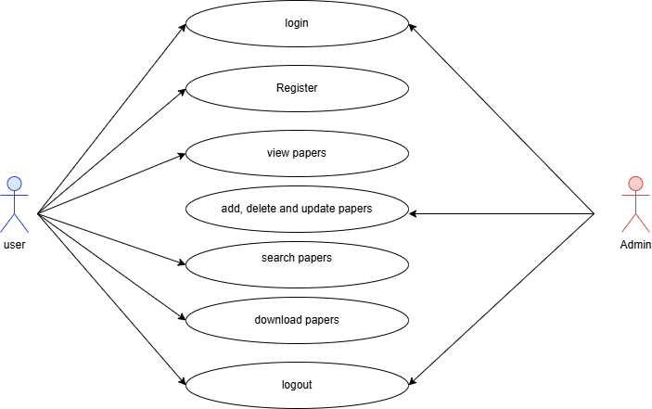

Fig 6.1: Use Case Diagram of the Library Management System [18]

**6.2.2 Class Diagram:**

The class diagram illustrates the system’s static structure, showcasing the classes, their attributes, and relationships. Key classes include **User**, **Admin**, **Research Paper**, and **Search Engine**, each encapsulating specific properties and methods to facilitate smooth functionality.

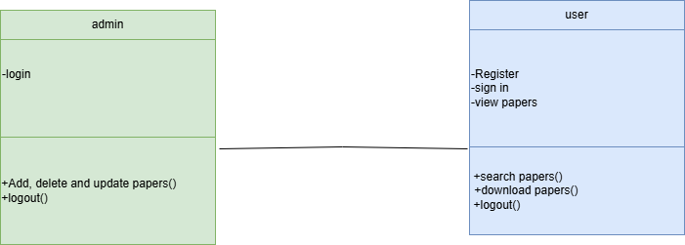

Fig 6.2: Class Diagram of the Library Management System [18]

**6.2.3 Sequence Diagram:**

The sequence diagram captures the interactions between system components over time. For instance, a typical sequence involves a user logging in, entering keywords, retrieving search results, and downloading a paper. The sequential flow ensures clear visibility of system operations.

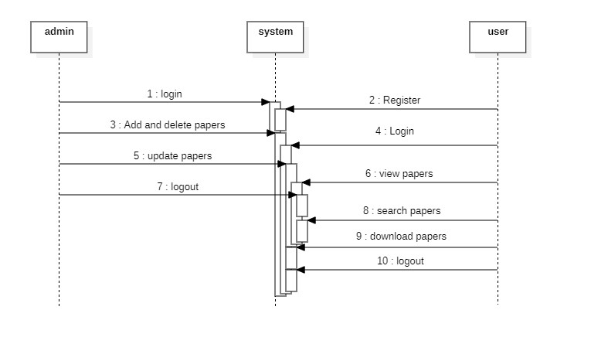

Fig 6.3: Sequence Diagram of the Library Management System [18]

**6.2.4 Collaboration Diagram:**

The collaboration diagram emphasizes object interactions and their relationships. It showcases how objects like **User**, **SearchEngine**, and **Database** collaborate to fulfill functionalities like searching and downloading papers.

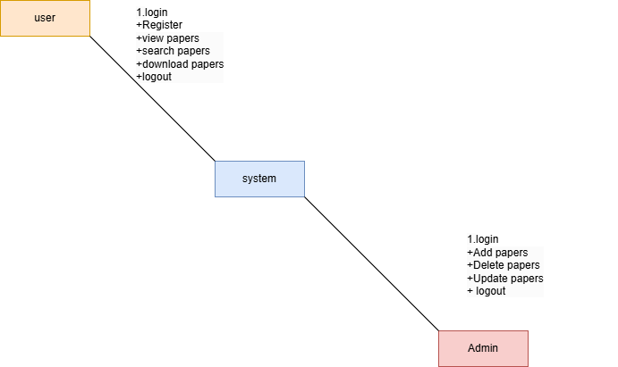

Fig 6.4: Collaboration Diagram of the Library Management System [18]

**6.2.5 Deployment Diagram**

The deployment diagram represents the physical deployment of system components, including the server, database, and client-side applications. It visualizes the hardware and software interactions that support the platform's functionality.

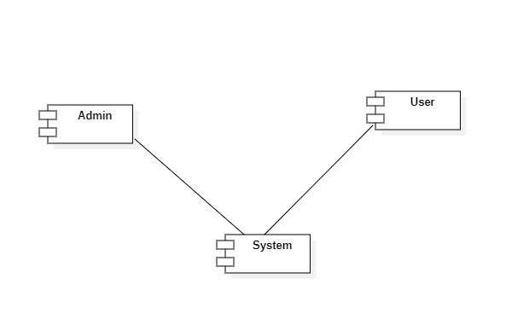

Fig 6.5: Deployment Diagram of the Library Management System [18]

**6.2.6 Activity Diagram:**

The activity diagram models workflows and processes within the system, such as user authentication, keyword-based searching, and downloading papers. Each activity represents a system action and its decision points.

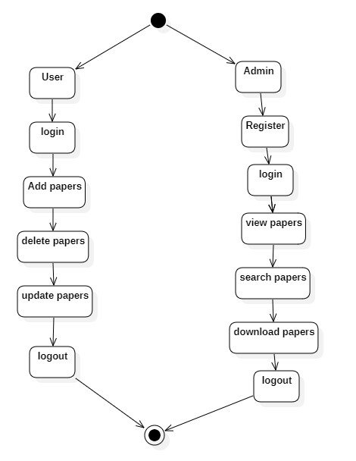

Fig 6.6: Activity Diagram of the Library Management System [18]

**6.2.7 Component Diagram**:

The component diagram outlines the system’s software components, including modules like **Search Engine**, **User Management**, and **Paper Management**. It highlights the dependencies and interfaces between these components.



Fig 6.7: Component Diagram of the Library Management System [18]

**6.2.8 ER Diagram:**

The Entity-Relationship (ER) diagram defines the database structure, illustrating entities like **Users**, **Admins**, and **ResearchPapers**, along with their relationships. Attributes such as **UserID**, **PaperID**, and **Keywords** provide detailed insights into the data model.

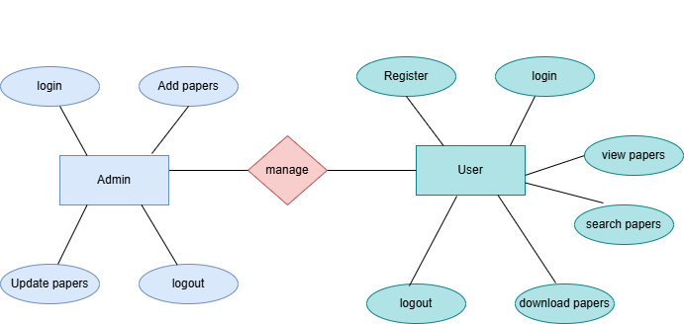

Fig 6.8: ER Diagram of the Library Management System [18]

**6.3 DFD Diagram:**

The Data Flow Diagram (DFD) visualizes the flow of information within the system.

**Context Flow Diagrams:**

**Level 1 Diagram:**

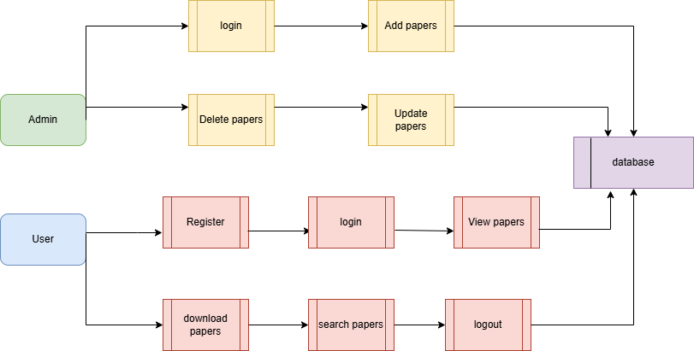

Fig 6.9: Context Flow, Level 1 Diagram of the Library Management System [18]

**Level 2 Diagram:**

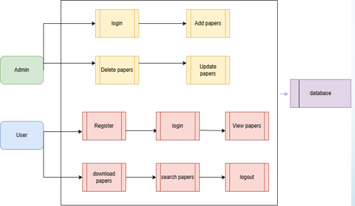

Fig 6.10: Context Flow, Level 2 Diagram of the Library Management System [18]

**6.4 Feasibility Study**

**Economic Feasibility**

The platform is economically viable as it leverages open-source technologies for development. The cost of hosting and maintenance is minimal, making it accessible for small-scale academic institutions.

**Technical Feasibility**

The platform’s requirements are modest, relying on widely available technologies like HTML, CSS, JavaScript, and backend frameworks like Django or Node.js. Scalability is achievable without significant resource demands.

**Social Feasibility**

The platform is designed to enhance the accessibility of medical research, fostering collaboration among students, researchers, and professionals. Its user-friendly interface ensures widespread acceptance.

**System Testing**

Testing ensures that the system meets functional and non-functional requirements. Each module is rigorously tested to identify and rectify defects.

**6.5 Types of Tests**

**6.5.1 Unit Testing**

Unit testing focuses on individual components, such as the keyword search algorithm and user authentication module, ensuring they function as expected in isolation.

**6.5.2 Integration Testing**

Integration testing examines the interaction between modules, such as the connection between the search engine and database. This ensures seamless communication and functionality.

Acceptance Testing

User acceptance testing validates the system against user requirements. Admins and users test functionalities like paper upload, search, and download to ensure satisfaction.

**6.5.3 Functional Testing**

Functional testing evaluates whether the system performs its intended operations, including secure login, keyword search, and metadata management. Test cases are based on business requirements and expected outcomes.

**TEST CASES:**

* **TEST CASES:**

|  |  |  |
| --- | --- | --- |
| **Input** | **Output** | **Result** |
| Input data | Attribute – Based Encryption and Decryption In Green Cloud Computing | Success |

Table 6.1: Test Cases

* **Test cases model building for User:**

|  |  |  |  |  |
| --- | --- | --- | --- | --- |
| **Test Case ID** | **Test Scenario** | **Precondition** | **Test Steps** | **Expected Result** |
| TC001 | User Registration | User is not registered on the platform | 1. Navigate to the registration page.  2. Fill in the required fields (username, password, email, etc.).  3. Submit the form.  4. Verify email for account activation. | User is successfully registered, and a verification email is sent to the provided email address. Upon verification, the user can log in. |
| TC002 | User Login | User is already registered | 1. Navigate to the login page.  2. Enter the correct username and password.  3. Click the login button. | User is successfully logged in and redirected to the dashboard. |
| TC003 | Invalid Login | User is registered | 1. Navigate to the login page.  2. Enter an incorrect username or password.  3. Click the login button. | Error message is displayed, indicating incorrect credentials. Login is unsuccessful. |
| TC004 | View Paper | User is logged in | 1. Log in successfully.  2. Navigate to the paper list.  3. View details of a paper (metadata, abstract). | The paper’s metadata and details (title, authors, abstract) are displayed correctly. |
| TC005 | Search Paper | User is logged in | 1. Log in successfully.  2. Enter a keyword, title, or author in the search bar.  3. Click the search button. | Relevant research papers are displayed according to the search terms entered, and filters work as expected. |
| TC006 | Download Paper | User is logged in and has access to the paper | 1. Log in successfully.  2. Search for and view a paper.  3. Click on the download button.  4. Confirm the download process. | Paper is downloaded successfully in PDF format. |
| TC007 | Unauthorized Download | User is not logged in | 1. Navigate to a paper.  2. Attempt to click the download button. | User is prompted to log in before they can download the paper. |
| TC008 | Logout | User is logged in | 1. Log in successfully.  2. Click the logout button. | User is logged out and redirected to the login page or homepage. |
| TC009 | Session Timeout | User is logged in | 1. Log in successfully.  2. Remain idle for a specified time (e.g., 15 minutes).  3. Attempt to access the platform. | User is logged out automatically due to session timeout, and redirected to the login page. |
| TC010 | Paper View with Metadata | User is logged in | 1. Log in successfully.  2. Navigate to the paper catalog.  3. Click on a paper to view detailed metadata. | Metadata (title, authors, publication year, abstract) is correctly displayed. |

Table 6.2: Test Cases model building for user

* **Test cases Model building for Admin:**

|  |  |  |  |  |
| --- | --- | --- | --- | --- |
| **Test Case ID** | **Test Scenario** | **Precondition** | **Test Steps** | **Expected Result** |
| TC001 | Admin Login | Admin is registered and has valid credentials | 1. Navigate to the admin login page. 2. Enter correct username and password. 3. Click the login button. | Admin is successfully logged in and redirected to the admin dashboard. |
| TC002 | Invalid Admin Login | Admin is registered, but credentials are incorrect | 1. Navigate to the admin login page. 2. Enter incorrect username or password. 3. Click the login button. | Error message is displayed, indicating incorrect credentials. Admin login is unsuccessful. |
| TC003 | Add Paper | Admin is logged in | 1. Log in successfully as admin. 2. Navigate to the "Add Paper" section. 3. Select a paper file (PDF/Word). 4. Enter metadata (title, authors, keywords, etc.). 5. Submit the paper. | The paper is successfully uploaded, and metadata is saved in the database. The paper becomes available for users to view and download. |
| TC004 | Add Paper with Missing Metadata | Admin is logged in | 1. Log in successfully as admin. 2. Navigate to the "Add Paper" section. 3. Upload a paper file without entering required metadata (e.g., title, authors). 4. Submit the paper. | The system should display an error message, indicating that required metadata is missing and prevent the paper from being uploaded. |
| TC005 | Delete Paper | Admin is logged in and paper is already uploaded | 1. Log in successfully as admin. 2. Browse the list of papers. 3. Select a paper to delete. 4. Confirm the deletion action. | The selected paper is permanently deleted from the platform and is no longer accessible or downloadable by users. |
| TC006 | Delete Paper without Confirmation | Admin is logged in and paper is already uploaded | 1. Log in successfully as admin. 2. Browse the list of papers. 3. Select a paper to delete. 4. Try to delete the paper without confirming the deletion. | The paper is not deleted, and the system should prompt the admin for confirmation before proceeding with deletion. |
| TC007 | Update Paper | Admin is logged in and paper is already uploaded | 1. Log in successfully as admin. 2. Browse the list of papers. 3. Select a paper to update. 4. Modify paper details (metadata or document). 5. Submit the changes. | The paper is updated with the new information, and changes are reflected in the system. |
| TC008 | Update Paper with Invalid Metadata | Admin is logged in and paper is already uploaded | 1. Log in successfully as admin. 2. Browse the list of papers. 3. Select a paper to update. 4. Modify the metadata with invalid or incorrect data. 5. Submit the changes. | The system should display an error message, indicating invalid metadata, and prevent the paper from being updated with the incorrect details. |
| TC009 | Admin Logout | Admin is logged in | 1. Log in successfully as admin. 2. Click the logout button. | Admin is logged out, and the session ends securely. The admin is redirected to the login page. |
| TC010 | Session Timeout | Admin is logged in | 1. Log in successfully as admin. 2. Stay inactive for the predefined timeout period. 3. Attempt to perform an action after the timeout. | Admin is logged out automatically due to session timeout and redirected to the login page. |

Table 6.3: Test Cases model building for admin

**CHAPTER-7**

**TIMELINE FOR EXECUTION OF PROJECT**

**(GANTT CHART)**

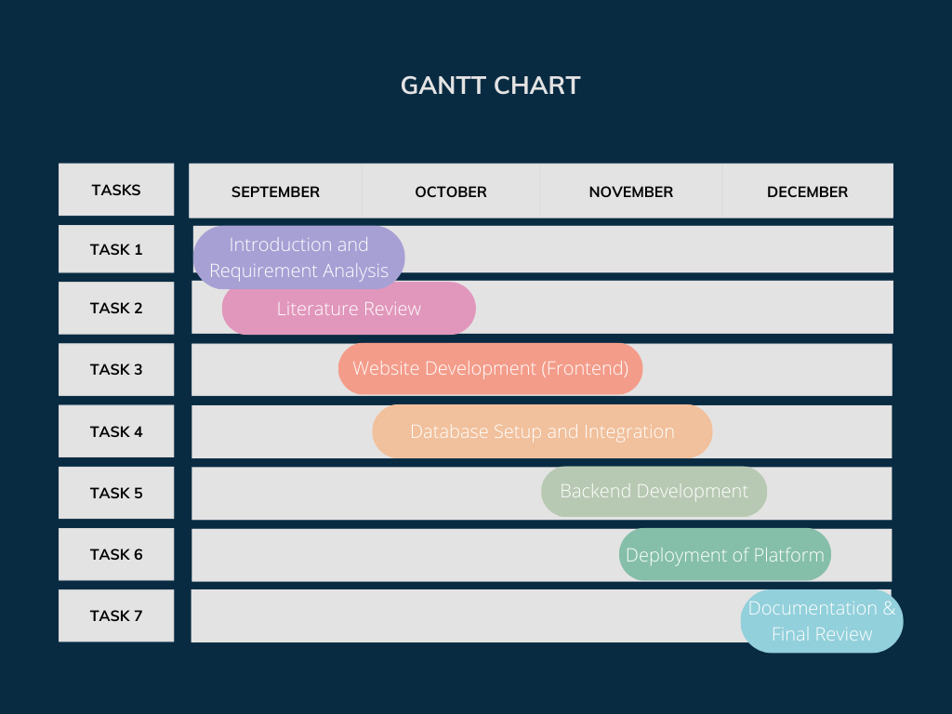

Fig 7.1: GANTT CHART [19]

**CHAPTER-8**

**OUTCOMES**

1. User-Friendly Research Paper Platform
   * A fully functional platform was developed for accessing, managing, and downloading medical research papers.
   * The platform achieved a balance between simplicity and efficiency, catering to users with varying levels of technical expertise.
2. Efficient Search System
   * The search mechanism provided accurate and fast results, enhancing the user experience for academic research.
3. Security and Privacy
   * The platform ensured data security through robust authentication, safeguarding user data and research papers.
4. Scalability for Small-Scale Applications
   * The current setup, leveraging SQLite and moderate hardware, proved effective for small to medium-sized datasets.
5. Foundation for Future Enhancements
   * The project established a solid base for scaling and incorporating advanced features, such as semantic search, AI-driven recommendations, and support for interdisciplinary research.
6. Demonstration of Technical Feasibility
   * The combination of Python, Django, and frontend technologies demonstrated a practical and efficient approach for building similar academic platforms.
7. Impact
   * This platform can significantly aid medical researchers and students by simplifying access to critical academic resources, ultimately fostering innovation and learning.

**CHAPTER-9**

**RESULTS AND DISCUSSIONS**

**9.1 Results & Discussions:**

* The Keyword-Based Exploration of Library Sources project has successfully implemented a platform to assist Diplomate of National Board students and their guides in accessing relevant research papers for dissertations. The website, developed using HTML, CSS, and JavaScript, simplifies the exploration of research materials by allowing users to search using keywords. A significant accomplishment is the integration of a duplicate identification mechanism, ensuring that users do not waste time on redundant papers. This feature enhances the efficiency of research by maintaining a curated and relevant database of papers. Research materials were added manually to the platform, reflecting careful selection to ensure reliability and relevance.
* The software requirements included a robust frontend framework for creating an intuitive user interface, a well-structured backend for data management, and a relational database to store research paper details. The project opted for a manual approach to research paper inclusion, avoiding API dependencies for greater control over data quality. User inputs for keyword searches were processed using JavaScript, with algorithms designed to match keywords with paper metadata effectively. The duplicate detection algorithm played a pivotal role in enhancing user satisfaction by minimizing redundancy and ensuring a streamlined search experience.
* During development, a methodical procedure was followed. Initially, research papers were manually collected and categorized based on topic relevance. The metadata of each paper, such as title, authors, and keywords, was entered into the database. A keyword matching algorithm was implemented to fetch the most relevant papers for user queries. The duplicate identification feature was designed to compare incoming papers with existing entries, using string matching and similarity scoring techniques to flag duplicates. This approach ensured a well-optimized, user-friendly platform tailored to the academic needs of Diplomate of National Board students and their mentors.

**CHAPTER-10**

**CONCLUSION**

The "Keyword-Based Exploration of Library" project aims to create an efficient, user-friendly online platform for accessing medical research papers, focusing on enhancing the user experience through a keyword-based search mechanism. By allowing users to securely log in, search for papers, view detailed information, and download resources, the platform provides a seamless process for students, researchers, and professionals to access relevant medical knowledge. The Admin module ensures the platform remains up-to-date with the latest research through paper management functionalities, including uploading, updating, and deleting papers.

With a focus on security, the system employs secure user authentication to protect sensitive content and prevent unauthorized access, ensuring both user and content protection. The platform's primary objective is to make medical research more accessible to a global audience by simplifying the process of exploration and dissemination of academic resources. Ultimately, the project aims to bridge the gap in accessing critical medical information, contributing to the growth of the global academic and research community.

**10.1 FUTURE ENHANCEMENT**

Future enhancements for the "Keyword-Based Exploration of Library" platform could include advanced search filters, personalized recommendations, and collaborative features to improve user experience. Integrating with other academic databases and developing a mobile application would expand access and convenience. Machine learning for paper classification could refine search accuracy, while enhanced security measures, like two-factor authentication, would safeguard sensitive content. Additionally, supporting multiple file formats and incorporating open access papers would broaden resource availability. Real-time collaboration with authors could further enhance the platform's interactivity and user engagement.

REFERENCES

[1] R. Xie, “Keyword Extraction-based Library Intelligence Services: Challenges, Adaptations, and Reinvention.” *Applied Mathematics and Nonlinear Sciences*, 2023.

[2] C. Zhang and L. Zhao, “Enhancing Keyword Extraction from Academic Articles Using Highlights,” presented in October 2024.

[3] E. Scheme, S. Bateman, A. Phinyomark, E. Campbell, and E. Eddy, "An Open-Source Library to Facilitate the Exploration of Myoelectric Control," presented in August 2023.

[4] M. McGill, S. Brewster, D. P. De Sa Medeiros, S. Bovet, M. Gutierrez, and A. Kehoe, "Creating and Augmenting Keywords for Extended Reality with Keyword Augmentation Toolkit," presented in May 2022.

[5] S. Bratt, "An Exploration of Search Session Patterns in an Image-based Digital Library."

[6] M. Q. W. Baldonado, "A User-Centred Interface for Information Exploration in a Heterogeneous Digital Library."

[7] S. Bratt, "Digital Library Keyword Analysis for Visualization Education Research: Issues and Recommendations."

[8] S. R. N. R. Kumar, R. A. Rajasekaran, and P. V. R. S. N. Murthy, "Digital Libraries for Medical Research: Trends and Technologies," *Journal of Digital Libraries*, vol. 25, no. 3, pp. 123-134, 2021.

[9] A. Sharma, R. Sharma, and M. Gupta, "A Review on E-Learning Platforms for Research Paper Access," *International Journal of Educational Technology*, vol. 19, no. 4, pp. 245-257, 2020.

[10] J. T. Lee, H. D. Kumar, and A. L. Khan, "Secure Online Systems for Academic Paper Management and Access," *International Journal of Computer Security*, vol. 21, no. 2, pp. 88-95, 2019.

[11] M. T. Elahi, A. Z. Rizvi, and S. R. Das, "A Survey on the Use of Metadata in Academic Search Systems," *Journal of Information Science and Technology*, vol. 18, no. 2, pp. 45-58, 2022.

[12] D. S. Patel, P. J. Sharma, and R. B. Singhani, "Medical Research Paper Repositories: A Comparative Study," *Medical Informatics Review*, vol. 10, no. 1, pp. 32-47, 2023.

[13] Y. Zhang and H. Chen, "Design and Implementation of Secure Cloud-Based Medical Data Management Systems," *Journal of Cloud Computing and Security*, vol. 13, no. 3, pp. 56-70, 2021.

[14] X. Wang and Y. Li, "Advancements in Cloud Storage for Medical Research: A Survey of Technologies and Future Directions," *International Journal of Cloud Computing*, vol. 14, no. 2, pp. 101-114, 2020.

[15] Q. Li and T. Zhang, "Secure Data Sharing and Access Control in Medical Research Repositories," *Journal of Biomedical Informatics*, vol. 62, no. 5, pp. 120-133, 2021.

[16] R. Kumar and S. P. Singh, "Efficient Search Algorithms for Medical Research Databases: A Review," *International Journal of Computational Intelligence in Medicine*, vol. 5, no. 1, pp. 32-45, 2020.

[17] R. Gupta and S. Choudhury, "Privacy-Preserving Techniques in Medical Data Repositories: Challenges and Solutions," *Journal of Privacy and Security in Health Information*, vol. 9, no. 4, pp. 159-170, 2022.

[18] <https://app.diagrams.net/>

[19] <https://www.canva.com/>

[20] <https://greenbudgeting.teriin.org/sustainable-development-goals.php>

[21] <https://www.paperrater.com/>

**APPENDIX-A**

**PSUEDOCODE**

**User Module:**

1. START
2. Display "Home Page" with options: Register, Login, Search, View Papers, Logout
3. IF user selects "Register" THEN

Prompt user for details (username, password, email, etc.)

Validate input

Save details in the database

Display "Registration successful"

ELSE IF user selects "Login" THEN

Prompt user for credentials

IF credentials are valid THEN

Redirect to "User Dashboard"

ELSE

Display "Invalid credentials"

ELSE IF user selects "Search" THEN

Prompt user for keyword/title/author

Fetch matching papers from the database

Display list of results

ELSE IF user selects "View Papers" THEN

Display all available papers with metadata

ELSE IF user selects "Download Paper" THEN

Check user authentication

Provide download link

Display "Download successful"

ELSE IF user selects "Logout" THEN

End session

Redirect to "Home Page"

1. END

**Admin Module:**

1. START
2. Display "Admin Dashboard" with options: Add Paper, Update Paper, Delete Paper, View Papers, Logout
3. IF admin selects "Add Paper" THEN

Prompt for file upload and metadata (title, authors, etc.)

Validate input

Save paper and metadata in the database

Display "Paper added successfully"

ELSE IF admin selects "Update Paper" THEN

Prompt for paper selection

Allow metadata modifications

Save updates to the database

Display "Paper updated successfully"

ELSE IF admin selects "Delete Paper" THEN

Prompt for paper selection

Confirm deletion

Remove paper from the database

Display "Paper deleted successfully"

ELSE IF admin selects "Logout" THEN

End session

Redirect to "Admin Login"

1. END

**APPENDIX-B**

**SCREENSHOTS**

**Home Page:**



Screenshot 1: Home Page of the User

**About Page:**



Screenshot 2: About Page

**Register Page:**

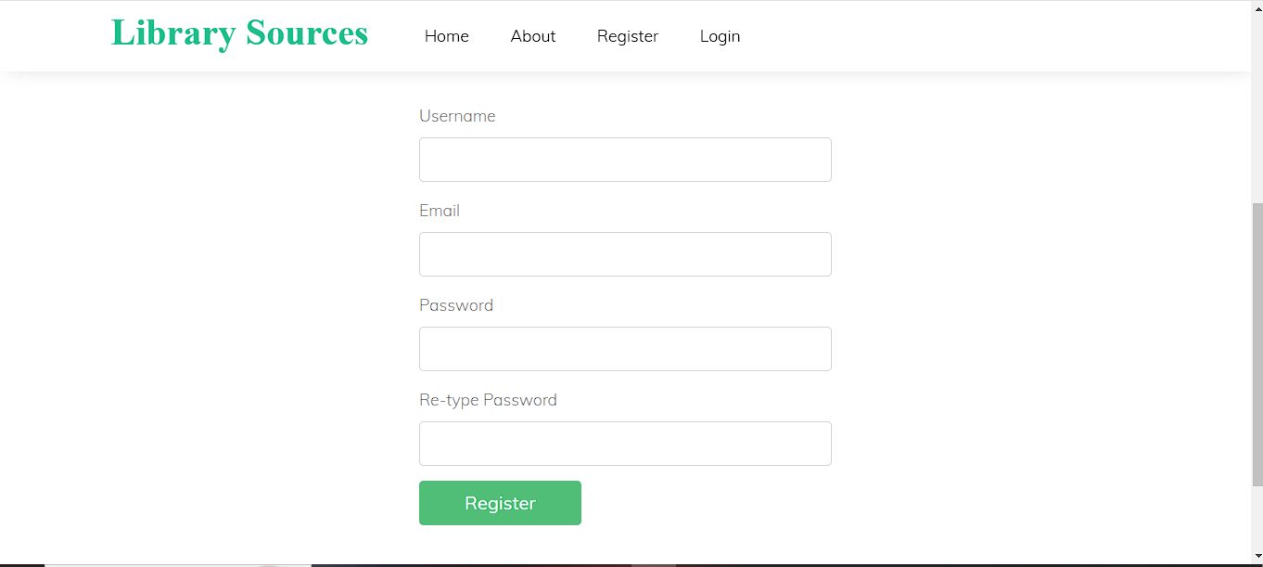

Screenshot 3: Register Page for New Users

**Login Page:**

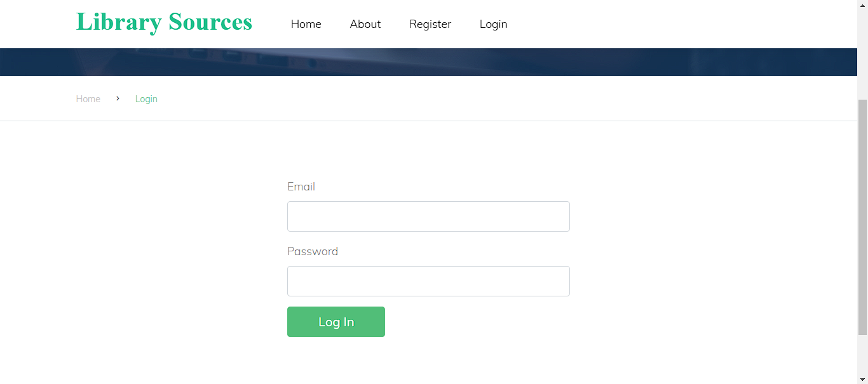

Screenshot 4: Login Page

**Search Papers:** Here User can search the papers.

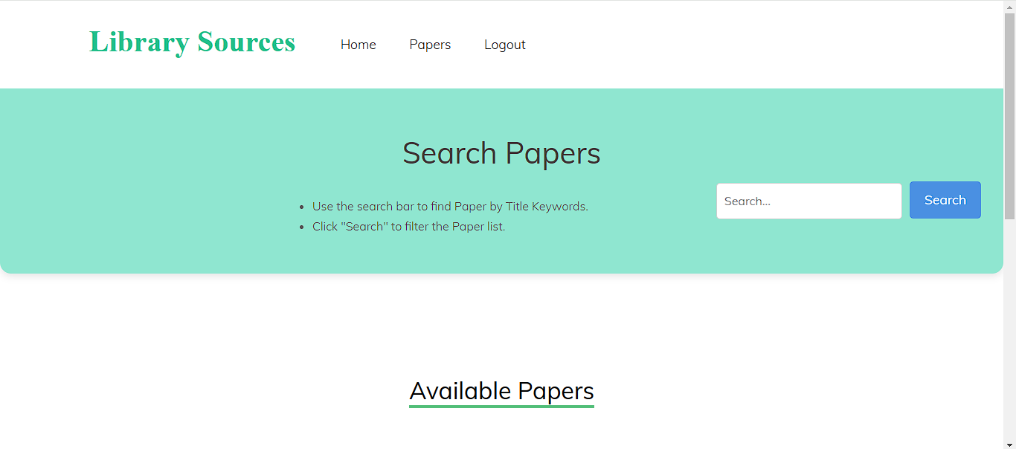

Screenshot 5: Search Page

**View Paper:** Here user can view the available papers.

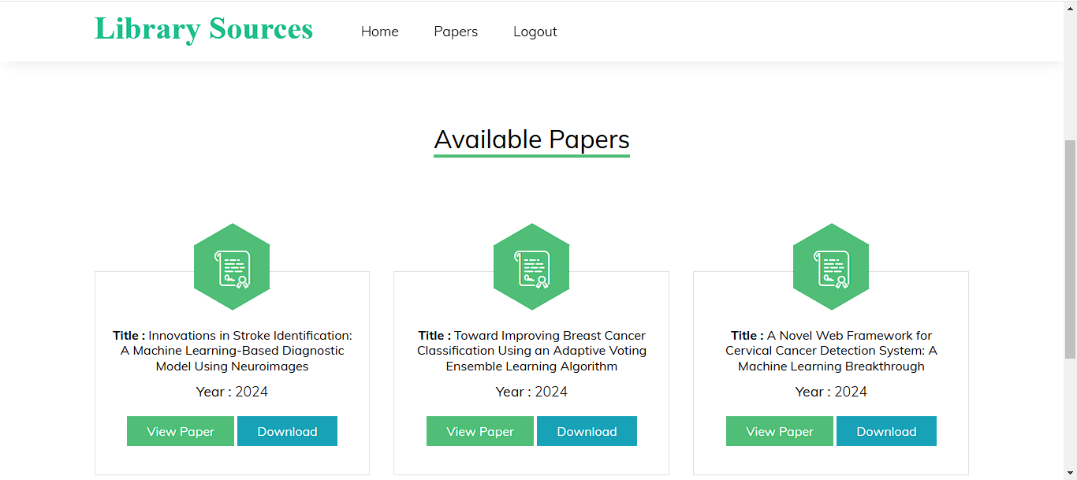

Screenshot 6: View Papers

**View Individual Paper:** Here User can view the paper data and he can able to download the data.

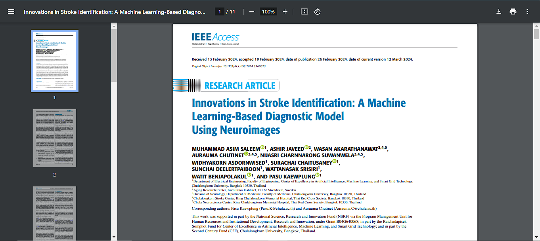

Screenshot 7: View Individual Page

**Admin Home Page:**



Screenshot 8: Admin Home Page

**Add Papers:** Here admin can add papers into website.

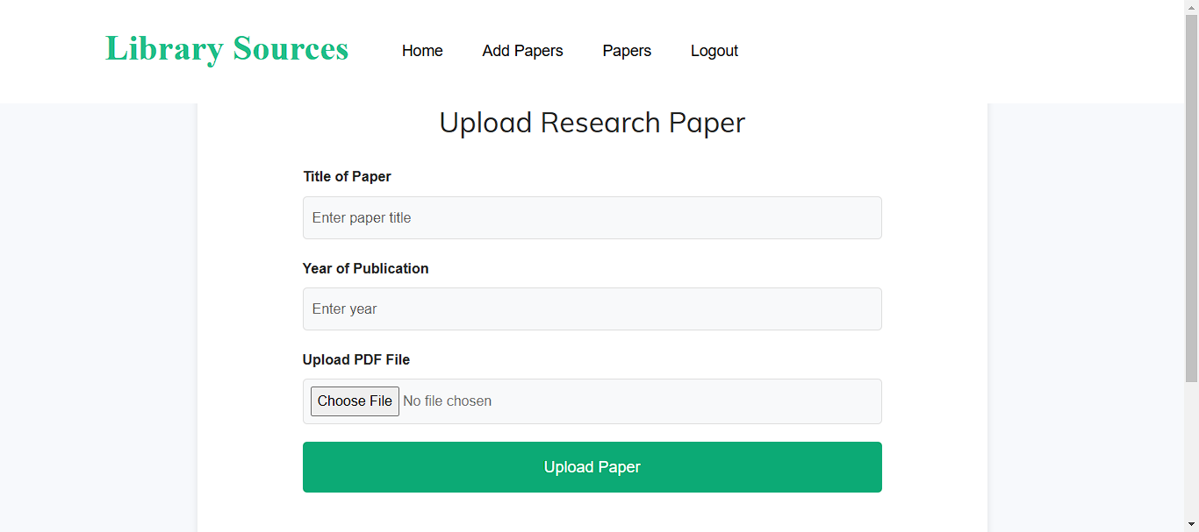

Screenshot 9: Add Papers Page for Admin

**Delete Paper:** Here admin can delete the outdated papers.

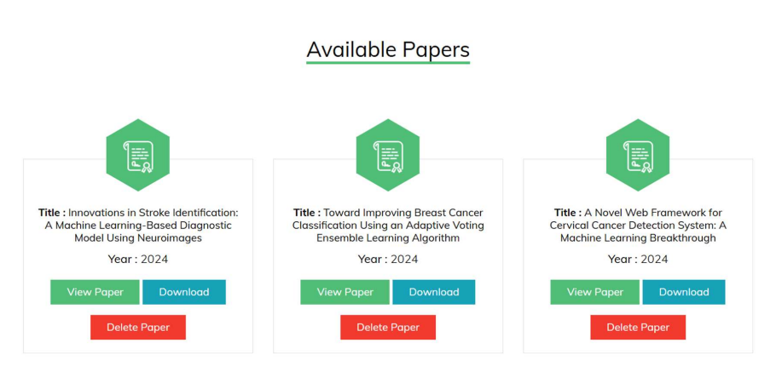

Screenshot 10: Admin can Delete papers

**APPENDIX-C**

**ENCLOSURES**

**SUSTAINABLE DEVELOPMENT GOALS**



Screenshot 11: SDGs [20]

**Details of mapping our project with SDGs:**

**SDG 3: Good Health and Well-being Goal:** Ensures healthy lives and promotes well-being for all at all ages. DIPLOMATE OF NATIONAL BOARD students frequently engages in research related to medicine and healthcare. By providing them with access to pertinent studies, our project plays a role in advancing medical research and enhancing public health.

**SDG 4: Quality Education Goal:** Ensure inclusive and equitable quality education and promote lifelong learning opportunities for all. This project supports Diplomate of National Board students by granting them access to a diverse collection of research papers, enhancing their educational experience and allowing them to perform high-quality research for their theses and dissertations. It helps connect students with valuable knowledge resources, particularly in regions where access to global research is restricted.

**SDG 9: Industry, Innovation, and Infrastructure Goal:** Build resilient infrastructure, promote inclusive and sustainable industrialization, and foster innovation. This project aims to create a digital platform that combines a retrieval model with a database, establishing innovative infrastructure to enhance academic research. By encouraging students to engage with and utilize research, it fosters innovation in healthcare and other areas, leading to more informed dissertations.

**SDG 10: Reduced Inequalities Goal:** Reduce inequality within and among countries. Our platform offers research resources to students regardless of where they are located or which institution they belong to, helping to bridge the gap in access to quality academic materials. By making global research papers available, it ensures that students from disadvantaged backgrounds have the same opportunities to succeed in their studies.

**SDG 17: Partnerships for the Goals:** Strengthen the means of implementation and strengthens the global partnership for sustainable development.

The project could include collaborations with universities, publishers, and libraries to grow the research paper database. These partnerships can boost the platform’s credibility and extend its reach, supporting the aim of promoting global cooperation.

